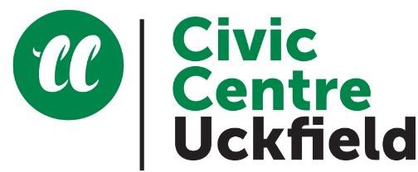
MEETING ROOMS AND VENUE HIRE

Additional equipment requirements

Charges from 1 April 2026

Date of venue hire:
Please tick any additional equipment you require for your booking. VAT at the standard rate will be added to the prices below. Please return this form with your booking form

Weald Hall only | Equipment hire rate | Please tick
Multi-height flexible staging – one third (7.3m x 1.83m) of the stage is permanently erected and may be used by any hirer at no extra charge | N/A | N/A
Two thirds stage (7.3m x 3.65m) | £12.00
Full stage (7.3m x 5.49m) | £24.50
Wheelchair lift to stage | No charge
Stage lights (first night) | £23.00
Stage lights (subsequent nights) | £15.50
Piano | £15.50
PA system and standard microphone | £17.50
Additional standard microphone | £4.50
Radio microphone | £11.50
Lapel of head microphone | £11.50
Induction loop for hard of hearing  *Please note – the hearing loop requires the PA system and microphone, and anyone using a hearing aid will need to select the ‘T’ setting. | No charge
All rooms | Equipment hire rate | Please tick
Wall-mounted digital smart screen and projector | No charge
Laptop | £6.00
Flipchart (pens provided) | £7.50
NOBO display boards (Velcro fastening) | £5.00
Lectern | £12.50
TV and DVD player | £8.00

MEETING ROOMS AND VENUE HIRE

Layout request form

Date of venue hire:

- Please tick the room layout you that you require from the sketches below
- If none of the examples is suitable, please attach your layout requirements to this form
- If various set ups are required for different rooms booked on the same day, please mark this clearly on this form.

Board Room | Classroom
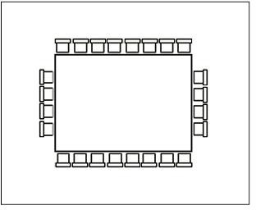 | 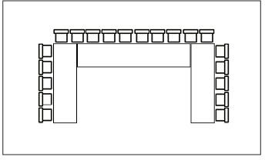
Cabaret | Theatre
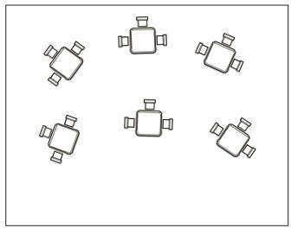 | 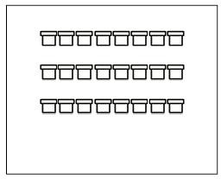
Chair semi circle | Other (please specify)
